SOFF Investment Phase

Funding Request

Version 2.0

12 September 2023

Systematic Observations Financing Facility

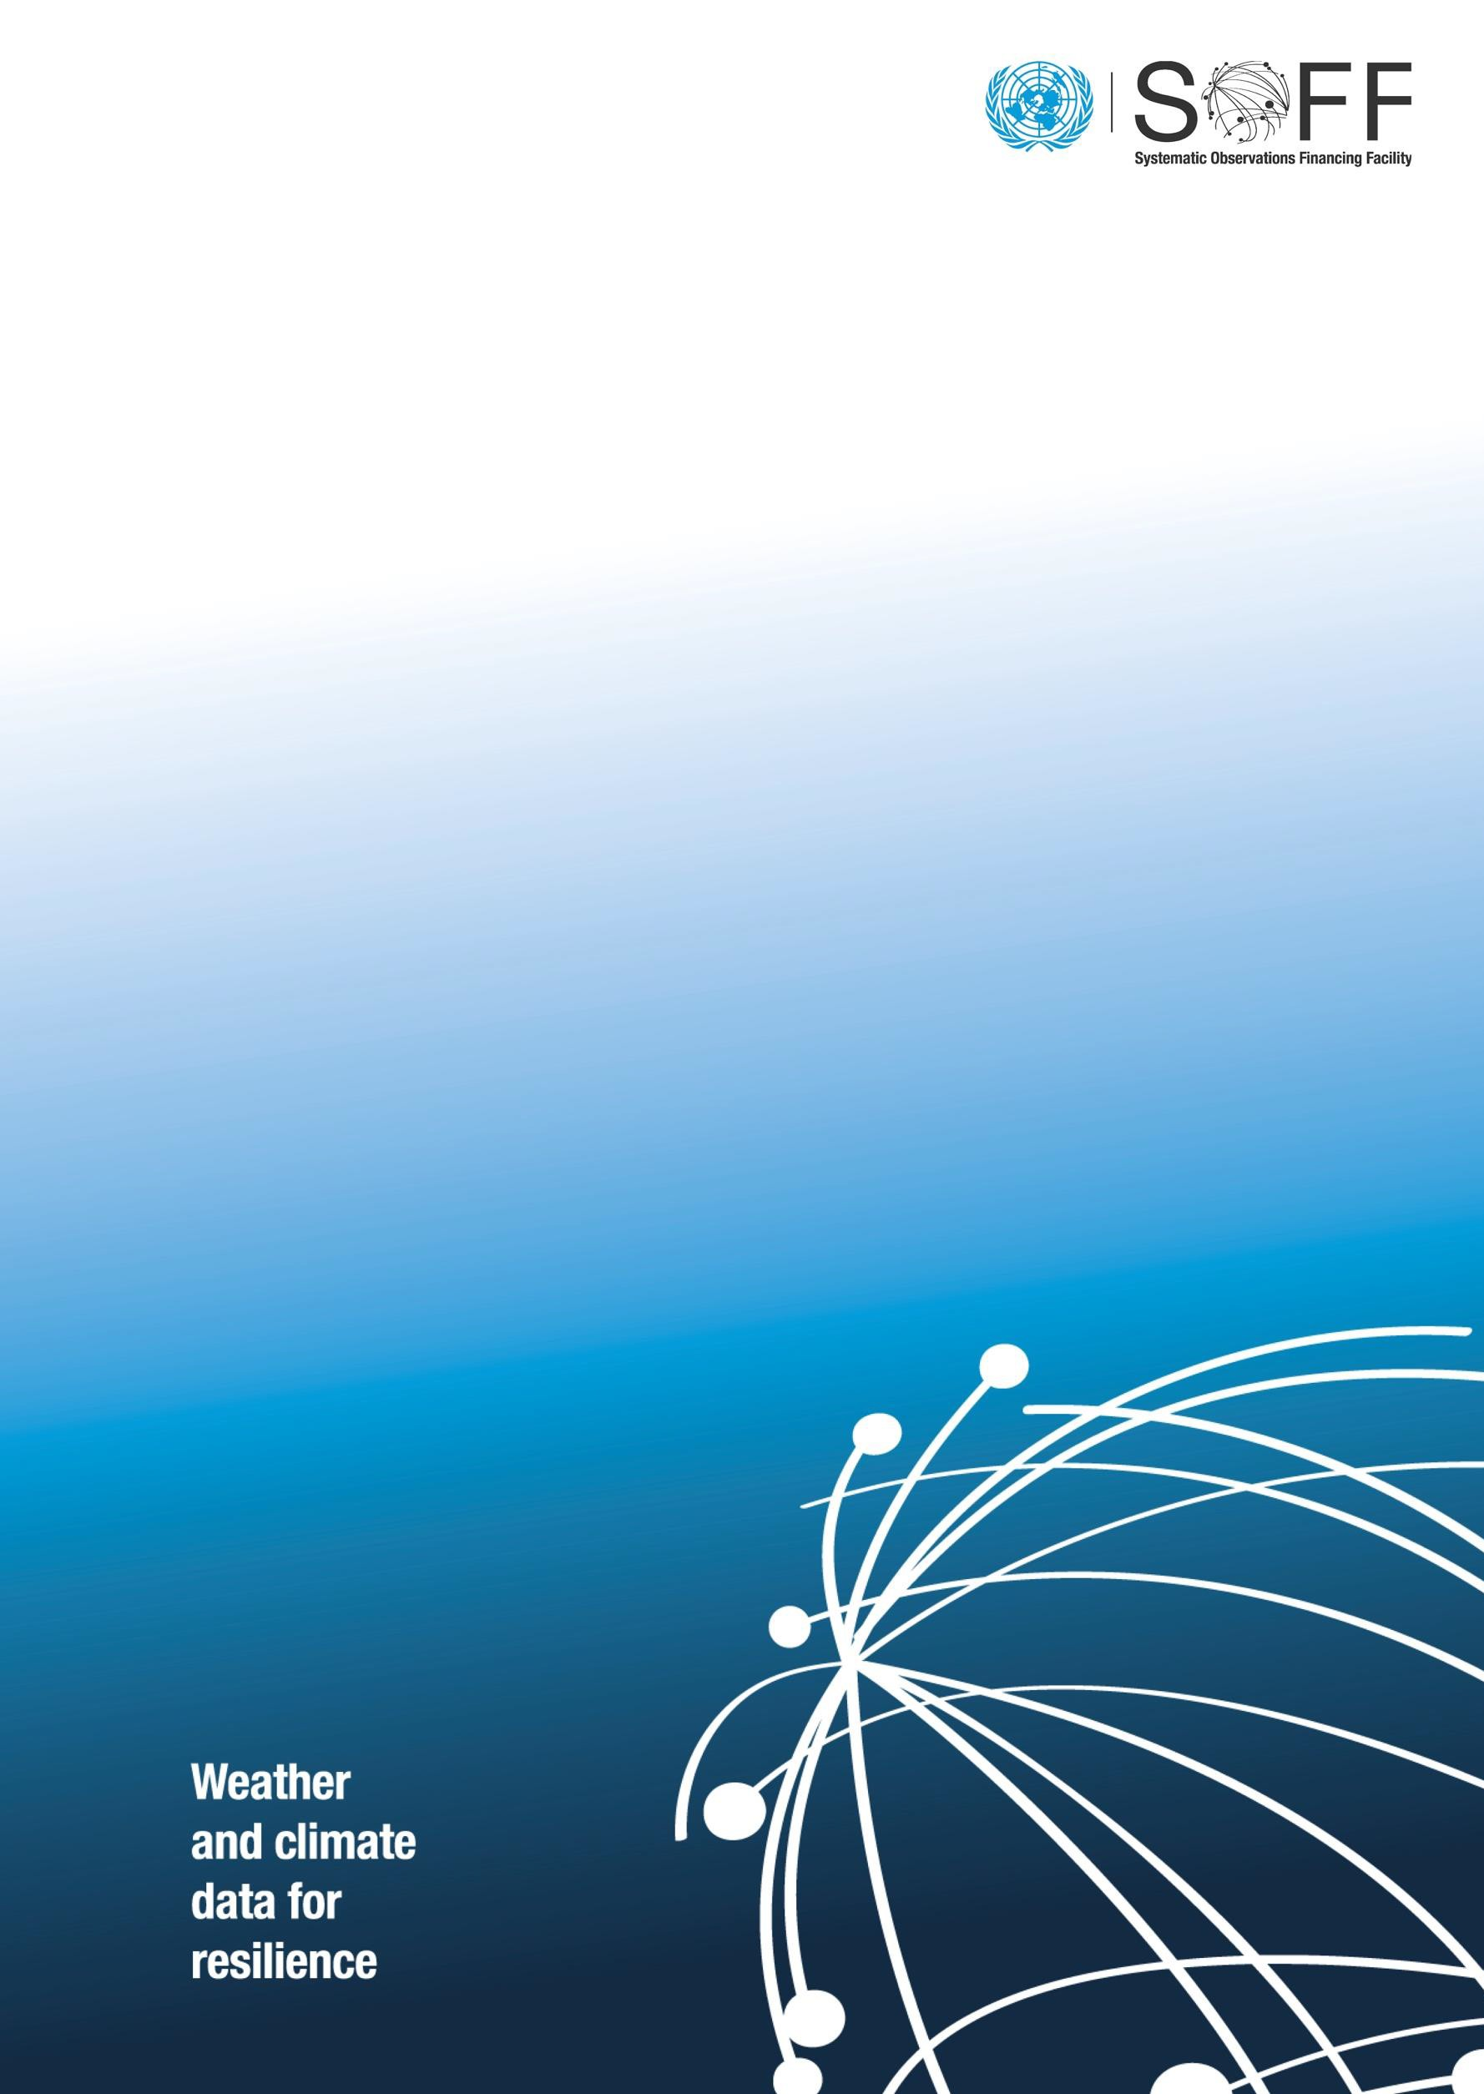

**SOFF Investment Phase Funding Request**

*The funding request should be prepared by the SOFF beneficiary country in collaboration with the SOFF implementing entity and supported by the SOFF peer advisor. The funding request reflects and is based on the National Contribution Plan. In case of questions on how to complete this template, please contact the SOFF Secretariat at:* [*soffsecretariat@wmo.int*](mailto:soffsecretariat@wmo.int)*.*

The SOFF Investment Funding Request template includes the following sections:

1. **Basic Information**
2. **Programming Criteria**
3. **Readiness and Country Context**
4. **Investment Phase Outputs and Budget**
5. **Investment Phase Implementation Arrangements**
6. **Investment Phase Monitoring, Reporting, and Verification**
7. **Investment Phase Risk Management Framework**

The **GBON Gap Analysis**, the **GBON** **National Contribution Plan** and **Country Hydromet Diagnostic** are included in **Annex 1, 2, 3**.

The **Terms of References** of the advisory services provided by the **SOFF peer advisor** are provided in **Annex 4.**

# Basic Information

|  |  |  |  |  |
| --- | --- | --- | --- | --- |
| **SOFF Beneficiary Country and Focal Point** | [Beneficiary country]  [Focal point name and contact information. The Focal point is WMO Permanent Representative or Head of NMHS] | | | |
| **Country classification** | LDC | SIDS | FCS | ODA-recipient |
| **SOFF Implementing Entity and Focal Point** | [Implementing Entity]  [Focal point name and contact information] | | | |
| **SOFF Peer Advisor and Focal Point** | [Peer Advisor]  [Focal point name and contact information] | | | |
| **Total Budget (USD)** | Please complete with the total Investment Phase budget and the amount requested for the two tranches (value and percentage).  Total:  First tranche:  Second tranche: | | | |
| **Delivery timeframe** | Please indicate specific months for the expected start and completion of the activities, including the commission period | | | |
| **Date of Steering Committee Approval** |  | | | |
| SOFF Steering Committee Co-Chairs Signature (signature confirms Steering Committee approval of the funding request) | | | | |

# SOFF Programming Criteria (2 pages)

|  |  |
| --- | --- |
| **Alignment with the SOFF Programming Criteria**  This section should be based on the SOFF Readiness Phase outputs, i.e. the National GBON Gap Analysis and GBON National Contribution Plan, and the Country Hydromet Diagnostic where available. | |
| **Close the most significant data gaps** | Please provide a brief summary regarding the GBON gap in the Beneficiary Country. |
| **Target easy fixes** | Please provide an overview of the opportunities for rehabilitation and improvement of existing observing infrastructure in the country and rapid delivery of GBON data sharing. |
| **Create leverage** | Please detail how SOFF investments are complementary to previous, ongoing, and planned operations in the beneficiary country by the SOFF Implementing Entities and other funds. Please state relevant ongoing or planned activities of the Implementing Entities in the beneficiary country. If the SOFF Investment program will be integrated within or complemented by a larger project or program of the Implementing Entity / Beneficiary Country, please identify the project or program and summarize alignment and leverage. |
| **Maximize delivery capacity** | Please outline the capacity of the Implementing Entity and any Executing Entities to deliver SOFF support efficiently and effectively in the country. |
| **Sub-regional gains** | Please state describe opportunities to create economies of scale and optimize the design of the GBON national networks through multi-country / sub-regional SOFF implementation, e.g., existing sub-regional cooperation or opportunities for sub-regional procurement and operations and maintenance. Explore opportunities for collaboration among Implementing Entities in the same region, where relevant. Please indicate how regional opportunities will be pursued during the Investment Phase implementation and any support required from the SOFF Secretariat. |

# Readiness and Country context (1 page)

|  |
| --- |
| **SOFF Beneficiary Country Capacity Assessment**  This section should summarize existing Beneficiary Country capacity to execute the GBON National Contribution Plan. |
| Based on the National GBON Gap Analysis and the requirements of the GBON National Contribution Plan, and complemented by the Country Hydromet Diagnostic where available, please provide an overview of Beneficiary Country technical, management, and administrative capacity for Investment Phase execution, including an assessment of the status of the NHMS and any other national and/or regional partners. |
| **Investment Phase Alignment with the GBON National Contribution Plan**  Please attach the National GBON Gap Analysis and GBON National Contribution Plan as Annex 1. |
| Please explicitly indicate and justify any differences in the proposed Investment Phase targets and the requirements of the GBON National Contribution Plan approved at the finalization of the Readiness Phase. |

# Investment Phase Outputs and Budget

The GBON National Contribution Plan provides detailed information on the Investment Phase Outputs (please see Annex 1).

Based on the recommendations and technical specifications provided in the National GBON Gap Analysis and GBON National Contribution Plan, and complemented by the Country Hydromet Diagnostic, please provide the required budget amount for the delivery of the Investment Phase Outputs.

|  |  |  |
| --- | --- | --- |
| **Output 1. GBON institutional and human capacity developed** | **Main activities** | **Budget (USD)** |
| 1.1 **National consultations** including with CSOs, and other relevant stakeholders conducted |  |  |
| 1.2 **NMHS institutional capacity** required to operate the GBON network developed |  |  |
| 1.3 **NMHS human capacity** required to operate the GBON network developed |  |  |
| **Output 2. GBON infrastructure in place** | **Main activities** | **Budget (USD)** |
| 2.1 **New land-based** stations and related equipment, ICT systems, data management systems and standard operating practices in place |  |  |
| 2.2 **Improved** **land-based** stations and related equipment, ICT systems, data management systems and standard operating practices in place |  |  |
| 2.3 **New** **upper-air** stations and related equipment, ICT systems, data management systems and standard operating practices in place |  |  |
| 2.4 **Improved** **upper-air** stations, related equipment, ICT systems, data management systems and standard operating practices in place |  |  |
| **Outcome: Sustained compliance with GBON** | **Main activities** | **Budget (USD)** |
| 3.1 **GBON land-based stations’** **commissioning period completed**, country-specific standard cost for operations and maintenance established, and data sharing verified by WMO Technical Authority |  |  |
| 3.2 **GBON upper air stations’ commissioning period completed**, country-specific standard cost for operations and maintenance established, and data sharing verified by WMO Technical Authority |  |  |
| **Total for all Outputs** |  |  |
| **Implementing Entity Fee[1]** |  |  |
| **SOFF peer advisory services** |  |  |
| **Total funding request** |  |  |
|  |  |  |
| **Budget breakdown by UNDG category**  **(Excluding SOFF peer advisory services)[2]** |  | **USD** |
| Staff and personnel costs | |  |
| Supplies, Commodities and Materials | |  |
| Equipment, Vehicles, Furniture and Depreciation | |  |
| Contractual Services Expenses | |  |
| Travel | |  |
| Transfers and Grants | |  |
| General Operating Costs | |  |

# Investment Phase Implementation Arrangements

|  |  |
| --- | --- |
| **Execution model and implementation arrangements** | Based on the Beneficiary Country Capacity Assessment, please detail the proposed Investment Phase execution model, including governance, implementation arrangements, coordination and management and implementation of activities, the roles and responsibilities of each Executing Partner, and the flow of funds (including an overview of relevant legal / financial instrument(s) to distribute the SOFF support). |
| **Private sector involvement** | Please indicate the anticipated role of the private sector according to the Business Models outlined in the [Operational Manual](https://www.un-soff.org/document/soff-operations-manual/), including relevant stakeholder engagement processes. |
| **Civil society participation** | Please indicate the anticipated role of civil society organizations, including relevant stakeholder engagement processes. |
| **Fiduciary systems** | Please provide an overview of the Investment Phase fiduciary arrangements, including financial management and procurement. |
| **Social and environmental safeguards** | Please provide an overview of the Investment Phase social and environmental safeguards, including gender policy. |
| **Dispute resolution mechanism** | Please provide an overview of the Investment Phase complaints management and conflict resolution mechanism. |
| **Additional relevant policies and procedures** | Please state any other policies and procedures that the Implementing Entity applies. |

# Investment Phase Monitoring and Reporting

The implementing entity, with the support of the peer advisor, is expected to monitor the implementation of the Investment Phase following an output-based approach. The Investment Phase outputs as well as respective indicators and targets are presented below. *Please indicate the implementation targets and adjust the table as needed to reflect the implementation timeline. Years can be added.*

|  |  |  |  |  |
| --- | --- | --- | --- | --- |
| **Output 1. GBON institutional and human capacity developed** | **Indicator** | **Target Y1** | **Target Y2** | **Target Y3** |
| 1.1 **National consultations** including with CSOs, and other relevant stakeholders conducted | As defined in the National Contribution Plan |  |  |  |
| 1.2 **NMHS institutional capacity** required to operate the GBON network developed |  |  |  |
| 1.3 **NMHS human capacity** required to operate the GBON network developed |  |  |  |
| **Output 2. GBON infrastructure in place** | **Indicator** | **Target Y1** | **Target Y2** | **Target Y3** |
| 2.1 **New land-based** stations and related equipment, ICT systems, data management systems and standard operating practices in place | # stations as per the GBON National Contribution Plan |  |  |  |
| 2.2 **Improved** **land-based** stations and related equipment, ICT systems, data management systems and standard operating practices in place | # stations as per the GBON National Contribution Plan |  |  |  |
| 2.3 **New** **upper-air** stations and related equipment, ICT systems, data management systems and standard operating practices in place | # stations as per the GBON National Contribution Plan |  |  |  |
| 2.4 **Improved** **upper-air** stations, related equipment, ICT systems, data management systems and standard operating practices in place | # stations as per the GBON National Contribution Plan |  |  |  |
| **Outcome: Sustained compliance with GBON** | **Indicator** | **Target Y1** | **Target Y2** | **Target Y3** |
| 3.1 **GBON land-based stations’** commissioning period[3] completed, country-specific standard cost for operations and maintenance established, and data sharing verified by WMO Technical Authority | # stations as per the GBON National Contribution Plan |  |  |  |
| 3.2 **GBON upper air stations’** commissioning period completed, country-specific standard cost for operations and maintenance established, and data sharing verified by WMO Technical Authority | # stations as per the GBON National Contribution Plan |  |  |  |

The implementing entity is expected to report on progress as described below.

* **Quarterly updates** to the SOFF Secretariat: A simple standardized form providing a progress update against the Investment Phase Outputs’ indicators (and Outcome, where applicable[4]) and flagging major issues that are delaying implementation, if any.
* **Annual narrative and financial reports** according to the UNMPTF reporting requirements indicated in the legal agreements. The annual narrative report reports on progress on the delivery of the Investment Phase Outputs, measured by the Investment Phase Indicators. It includes also a review of the Investment Phase risks and an update on environmental and social safeguards, including gender.
* **Final narrative and financial reports** according to the UNMPTF reporting requirements indicated in the legal agreements. The final narrative report confirms the completion of all the activities and report on the number of stations that have completed the commissioning period (outcome). The WMO technical authority verifies GBON compliance of the indicated stations and provides a verification report to the SOFF Secretariat. Upon WMO verification, the Investment Phase can be considered completed. The Final Report should describe the Investment Phase results achieved and lessons learned; and it should also specify the long-term institutional arrangements to secure sustained GBON compliance with SOFF Compliance Phase support.

# Investment Phase Risk Management Framework

The Investment Phase Risk Management Framework should be based on the [SOFF Risk Management Framework](https://alliancehydromet.org/wp-content/uploads/2023/04/Decision-4.2-SOFF-risk-managment-framework.pdf), incorporating relevant programmatic risks and including additional country-specific risks. Please follow the [methodology established by the Multi-Partner Trust Fund Office (MPTFO)](https://view.officeapps.live.com/op/view.aspx?src=https%3A%2F%2Fmptf.undp.org%2Fsites%2Fdefault%2Ffiles%2Fdocuments%2F20000%2Fundg_guidance_on_mdtfs_2015.docx&wdOrigin=BROWSELINK) presented below.

|  |  |  |  |  |  |  |
| --- | --- | --- | --- | --- | --- | --- |
|  | | **Impact** | | | | |
| **Insignificant (1)** | **Minor (2)** | **Moderate (3)** | **Major (4)** | **Extreme (5)** |
| **Likelihood** | **Very Likely (5)** | Medium (5) | High (10) | High (15) | Very High (20) | Very High (25) |
| **Likely (4)** | Medium (4) | Medium (8) | High (12) | High (16) | Very High (20) |
| **Possible (3)** | Low (3) | Medium (6) | High (9) | High (12) | High (15) |
| **Unlikely (2)** | Low (2) | Low (4) | Medium (6) | Medium (8) | High (10) |
| **Rare (1)** | Low (1) | Low (2) | Medium (3) | Medium (4) | High (5) |

Please complete the following table.

|  |  |  |  |  |
| --- | --- | --- | --- | --- |
| **Risk** | **Risk level** | **Likelihood** | **Impact** | **Risk Mitigation Measures** |
| Non-compliance with fiduciary and procurement standards in some SOFF activities | Please indicate: Low, Medium, High, Very high | Please indicate: Rare, Unlikely, Possible, Likely, Very likely | Please indicate: Insignificant, Minor, Moderate, Major, Extreme | Please indicate risk mitigation measures the project will undertake. |
| SOFF-funded investments cause environmental or social impacts |  |  |  |  |
| NMHS staff depart after being trained |  |  |  |  |
| Slow implementation and delays in procurement, installation and capacity building activities |  |  |  |  |
| After the conclusion of the Investment phase, GBON data are not collected or shared or are shared of insufficient quality |  |  |  |  |
| Destruction or theft of SOFF-financed equipment and infrastructure |  |  |  |  |
| Countries cannot make optimal use of data, including accessing or using improved forecasts products from the Global Producing Centers throughout the hydromet value chain |  |  |  |  |
| *Please add any additional, specific country risks* |  |  |  |  |
|  |  |  |  |  |
|  |  |  |  |  |

# Annex 1: National Gap Analysis

# Annex 2: National Contribution Plan

# Annex 3: Country Hydromet Diagnostics

# Annex 4: Terms of Reference for the provision of technical advisory services during the SOFF Investment Phase

1. **Purpose and scope**

These Terms of Reference describe the provision of technical advisory services by [*peer advisor name]* to [*SOFF beneficiary country*] to contribute to the delivery of the SOFF Investment Phase outputs as described in Section 3.

The Terms of Reference are based on the [SOFF Operational Manual](https://alliancehydromet.org/wp-content/uploads/2022/11/Decision-item-2.2-Adoption-of-the-SOFF-Operational-Manual.pdf), Section 4.4.3 on the Operational Partners and Section 4.5.2 on the Investment Phase; as well as on the [SOFF Investment Framework](https://www.un-soff.org/document/decision-5-8-soff-investment-phase-framework-and-funding-request-template/), Section 4.5 on the Peer Advisors and WMO Technical Authority.

1. **Roles and responsibilities**

**Beneficiary country National Meteorological and Hydrological Service**

* Is responsible for implementing the activities of the SOFF Investment Phase activities with the support of the Implementing Entity and the peer advisor.
* Submits the SOFF Investment Phase funding request using the standardized template provided by the SOFF Secretariat, including the Terms of References for the peer advisor’s technical advisory services during the Investment Phase.
* Is responsible for collaborating with the Implementing Entity to provide all the necessary information, participate in and facilitate the national activities that the Implementing Entity and peer advisor need to conduct in order to deliver the SOFF Investment Phase outputs.
* Confirms the completion of all the Investment Phase activities and provides comments as needed on the final report prepared by the Implementing Entity.

**Peer advisor**

* Is accountable to the beneficiary country and the Implementing Entity.
* Is contracted via the WMO pass-through mechanism and operates on a cost-recovery basis.
* Provides technical advisory services to support beneficiary countries and Implementing Entities in the design and implementation of the SOFF Investment Phase activities.
* Contributes to the final report of the SOFF Investment Phase.

**Implementing Entity**

* Prepares the Investment Phase funding request in collaboration with the beneficiary country and the peer advisor, including the Terms of References for the provision of technical advisory services during the SOFF Investment Phase.
* Manages the Investment Phase activities following the terms specified in the funding request and in collaboration with relevant national partners, including civil society organizations.
* Delivers the Investment phase outputs and is responsible for their quality and timely delivery, in coordination with the country and the peer advisor.
* Provides quarterly updates to the SOFF Secretariat according to a simple standardized form and annual reports according to the United Nations Multi-Partner Trust Fund Office’s reporting requirements indicated in the legal agreements.
* Informs the SOFF Secretariat of circumstances that could materially impede the implementation of the Investment phase or any considerable deviation in the conditions of the funding request to achieve its objectives.
* Submits the final report to the SOFF Secretariat including the beneficiary country’s comments and the peer advisors’ feedback. The final report describes the institutional arrangements to secure sustained operation and maintenance of the investments made.

**WMO Technical Authority**

* Provides basic on-demand technical assistance to the beneficiary country, Implementing Entity and peer advisor on GBON regulations, including on monitoring and assessing the data-sharing status of the stations using the WDQMS web tool[5]
* Is responsible for the verification of data sharing of the new or rehabilitated surface and upper -air stations as per GBON regulations.
* WMO provides a verification report to the SOFF Secretariat, upon which the Investment Phase can be considered completed.
* Establishes and administers the pass-through mechanism for contracting and funding of the advisory services provided by the peer advisors.

**SOFF Secretariat**

* Facilitates communication, coordination and collaboration between the beneficiary country, the Implementing Entity, the peer advisor and WMO Technical Authority.
* Reviews the SOFF Investment Phase funding request, including the Terms of Reference for the provision of technical advisory services and provides feedback as needed. Then transmits the funding request to the SOFF Steering Committee for their decision.
* Compiles quarterly updates and annual reports and monitors implementation based on information received from the Implementing entity, the peer advisor and the beneficiary country. Regularly informs the Steering Committee of progress.
* Coordinates regional implementation approaches to the SOFF Investment Phase.
* Confirms receipt of the final report by the Implementing Entity and completion of the Investment Phase based on WMO verification of data sharing.
* Organizes exchange of knowledge and experiences and captures lessons learned.

1. **Peer advisors’ activities during the SOFF Investment Phase**

*Please add here a detailed description of the advisory services to be provided by the peer advisors during the SOFF Investment Phase. These are expected to be tailored to the country. Potential areas of support may include providing technical advice related to bidding documents development, bid assessment and/or evaluation, ensuring the correct commissioning and initial operation of equipment, supporting dispute resolution with suppliers on technical matters, and/or staff training, capacity building, institutional strengthening and others.*

1. The implementation fee cannot exceed 7% of the total Investment Phase funding request.
2. The total budget (excluding the budget for the SOFF peer advisory services) is expected to be disaggregated by UNDG category. It includes direct and indirect costs of the Implementing Entity and beneficiary countries to establish a fully operational observation network, collecting and internationally exchanging data according to GBON requirements. Eligible expenditures are any type of expenditure required to implement the GBON National Contribution Plan, including the requirements of the beneficiary country to manage and administer the day-to-day activities of the Investment Phase. It also includes the budget required for the operation and maintenance of the observing network.
3. The commissioning period is the last year of the Investment Phase. The beneficiary country, supported by the Implementing Entity, must demonstrate the sustained operation of all the SOFF-supported stations according to the GBON compliance.
4. The quarterly reports should also include, when applicable, progress achieved in terms of new or rehabilitated stations that have become operational and are already sharing the data into the WIS 2.0 system as confirmed through the WIGOS Data Quality Monitoring System (WDQMS) web tool.
5. The WDQMS web tool monitors the availability and quality of observational data based on near -real-time information from the four participating global Numerical Weather Prediction centres: the German Weather Service (DWD), the European Centre for Medium range Weather Forecasts (ECMWF), the Japan Meteorological Agency (JMA) and the United States National Centers for Environmental Pre diction (NCEP). These are four of the ten World Meteorological Centres, designated by WMO to provide global numerical weather prediction products for all WMO Members.