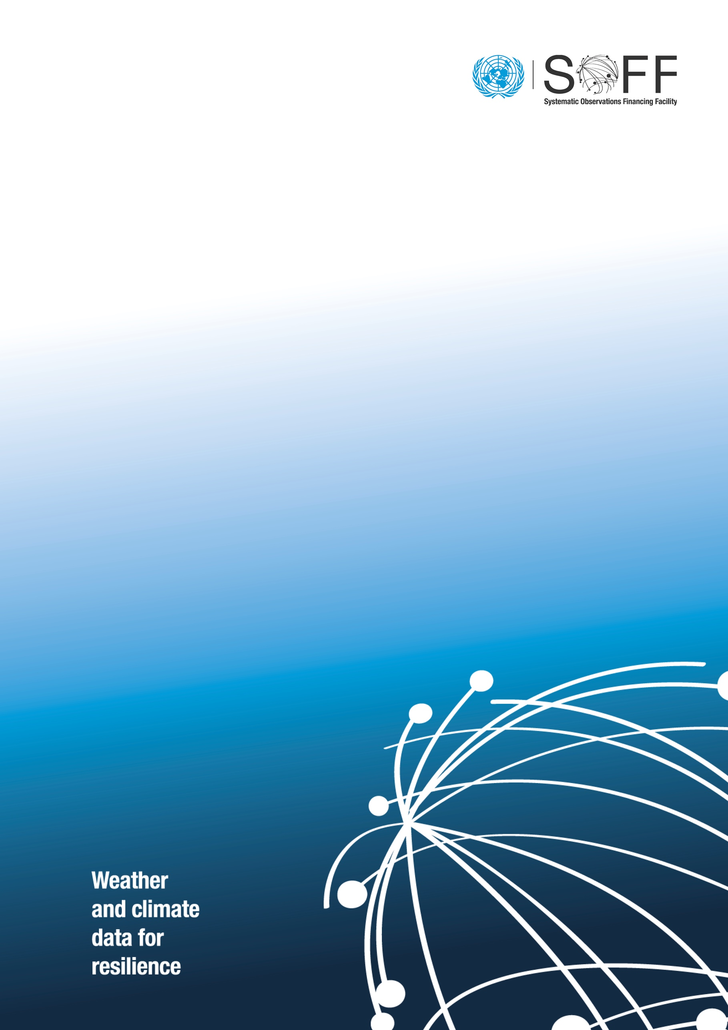

SOFF Semi-Annual Progress Report
(Version 1.2)

  - Systematic Observations
Financing Facility
May 2024

Semi Annual Progress Report
On the SOFF Readiness phase outputs
Beneficiary country:
Peer Advisor:
Output | Expected delivery date  (Based on the Assignment Agreement) | Status  (Completed/ Delayed) | Challenges | Proposed submission date | Estimated delivery date
National Gap Analysis
National Contribution Plan
Country Hydromet Diagnostics

Date, Month and Year
Signature of peer advisor focal point |  | Signature of beneficiary country focal point

For assignments for which the delivery of advisory services takes more than six months, the SOFF peer advisor shall submit a semi-annual progress report to the SOFF Secretariat

