Annex II D

Recommended practices for  
coordination and collaboration

between SOFF peer advisors and RWC

Regional WIGOS Centers (RWC) play a critical role in advancing the implementation of WIGOS within their region or subregion, providing regional coordination and technical support to WMO Members. The primary, mandatory functions of RWC are to support WMO Members with the management of metadata in OSCAR/Surface and to assist with following up on quality issues identified via the WIGOS Data Quality Monitoring System (WDQMS), including for GBON stations.

RWC may also contribute to the coordination of regional projects and support regional capacity development. The mandatory and optional functions can be seen on the image below:

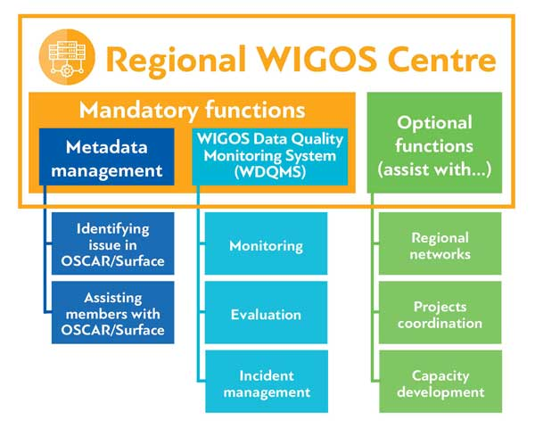

**Figure 1.** Mandatory and optional functions of RWC

The document outlines the roles, responsibility and envisioned coordination between RWC and SOFF peer advisors and operational partners in the implementation of SOFF Investments. It is crucial that RWC and peer advisors collaborate closely and regularly to ensure GBON implementation in SOFF countries in an efficient and coordinated way. This collaboration should be consistent and tailored to the specific needs of the countries. SOFF peer advisors and RWCs are recommended to implement the following collaboration practices:

# Collaboration during the readiness phase

* SOFF peer advisors should first consult with the country to identify if the country has been affiliated with one the RWC. List of RWCs and their affiliated countries can be seen here: [Existing RWC by WMO Region | World Meteorological Organization](https://community.wmo.int/en/activity-areas/WIGOS/implementation-WIGOS/Existing-RWC). SOFF peer advisors should contact the respective RWC, in coordination with WMO/SOFF Secretariat and Regional Associations coordinator for infrastructure, towards exchanging information and plan. For WMO Secretariat, please reach out to [wdqms-ims@wmo.int](mailto:wdqms-ims@wmo.int)
* If the country is not yet affiliated to an RWC, the peer advisor should evaluate which RWCs may prove suitable and liaise with the country to support their affiliation process.
* The SOFF peer advisor should provide the delivery timeline for readiness phase outputs of the country, while the RWC should provide input to the SOFF peer advisors on observation networks in the country, such as:
  + An overview of the status of relevant human capacity, including, National Focal Point (NFP) for WIGOS, OSCAR/Surface, and WDQMS, if known.
  + A status overview of the observational data and metadata performance, based on their regular reporting, in the context of RWC guidance.
  + Capacity development activities ongoing/planned, including any training provided/planned by the RWC to the country, and the list of staff that participated in previous training activities, and the list of staff that participated in previous training activities.
  + Other complementary information available at the RWC.
* All information provided by the RWC should be considered by peer advisor when drafting GBON National Contribution Plan.
* During the readiness phase, peer advisors and RWC are highly encouraged to synergize by working together to resolve any easy fix issues in the countries, such as:
  + Registering and improving GBON stations metadata in OSCAR/Surface.
  + Evaluating data availability and the quality of existing GBON stations.
  + Nominating the NFP for WIGOS, OSCAR/Surface and WDQMS.
* SOFF peer advisors might attend regional capacity development activities for WMO Members hosted by WMO or RWC to get familiar with RWC operations and WIGOS Tools.
* SOFF peer advisors might request RWC’s assistance in establishing linkages with the WIS centers, Regional Instrument Centers (RIC) and Regional Training Centers (RTC) in the region.

# Collaboration during the Investment phase

The collaboration during the investment phase is based on the SOFF Investment outputs, namely GBON infrastructure in place and GBON human and capacity developed. The collaboration includes:

* During the development of the investment proposals, peer advisors should consider the roles for RWC when identifying peer advisory services included in the SOFF investment proposal.
* Peer advisors and RWCs should collaborate in providing training and technical assistance to countries, especially those related to OSCAR/Surface, the WDQMS webtool and Incident Management System. SOFF peer advisors might request RWC to provide training for SOFF countries on those subjects.
* Peer advisors should support SOFF countries in following up on relevant data/metadata performance issues on GBON stations. This includes but not limited to:
  + Registering and improving GBON stations metadata in OSCAR/Surface.
  + Monitoring improvements achieved in data availability and quality using the WDQMS webtool.
  + Updating incident ticket status in the Incident Management System.

# Collaboration during the compliance phase

To be defined once the GBON compliance framework is available.