Annex II E

Short guidance on approaches for traceability assurance in GBON stations

The main objective of the calibration strategy for traceability assurance as defined under[Annex 1.B. Strategy for Traceability Assurance, Volume I, Chapter 1](https://library.wmo.int/viewer/68695/?offset=#page=57&viewer=picture&o=bookmark&n=0&q=) of the [Guide to Instruments and Methods of Observation](https://library.wmo.int/records/item/68695-guide-to-instruments-and-methods-of-observation?language_id=13&back=&offset=4) (WMO-No.8) is to ensure the proper traceability of measurement and calibration results to the International System of Units (SI), through an unbroken chain of calibrations, each contributing to the measurement uncertainty.

Lack of metrological traceability reduces the reliability of meteorological measurements, and consequently, reduces confidence in the implications of measurement data such as weather forecasts, warnings, and climate analyses. Observing systems, and related traceability assurance, must be designed so that the measurements meet the requirements of the users. It should be noted that numerous GBON stations are also being used by Members for other applications, such as climate monitoring.

A list of key definitions is provided in the Appendix to this document.

# Responsibilities for traceability assurance

**The responsibilities of the WMO Members** for traceability of the measurements are defined in Section 2.3 Instrumentation and Methods of Observation in the [Manual on WIGOS](https://library.wmo.int/records/item/55063-manual-on-the-wmo-integrated-global-observing-system?offset=3) (WMO-No.1160) summarized below:

* Members shall ensure that observations are traceable to the International System of Units (Système international d'unités (SI)) standards, where these exist.
* Members shall use properly calibrated instruments and sensors that provide observations satisfying at least measurement uncertainties that meet the specified requirements, including for emerging technologies.
* Members should describe uncertainty of observations and observational metadata as specified in the Guide to Instruments and Methods of Observation (WMO-No. 8), Volume I, Chapter 1, 1.6.

To achieve this, National Meteorological and Hydrological Services (NMHSs) of Members should develop and implement a proper strategy for traceability assurance in a sustainable manner.

# Providers of calibration services

Different types of laboratories can provide calibration services to Members’ NMHSs. Some of them will provide services to calibrate reference instruments only, while others may provide similar services for instruments that are deployed in the field. These include:

* National Metrology Institutes (NMIs): to calibrate reference instruments
* Regional Instrument Centres (RICs): to calibrate reference instruments
* Manufacturers: to calibrate field instruments and field verification kits
* Other public or private laboratories: to calibrate field and/or reference instruments and field verification kits depending on the services they offer
* Calibration laboratories of other NMHSs: to calibrate field and/or reference instruments and field verification kits depending on capabilities and capacities.

It is recommended to use the service of calibration laboratories that have an **ISO/IEC 17025 accreditation for the service provided**. If accreditation is not available, then it must be ensured that the laboratory is traceable to SI.

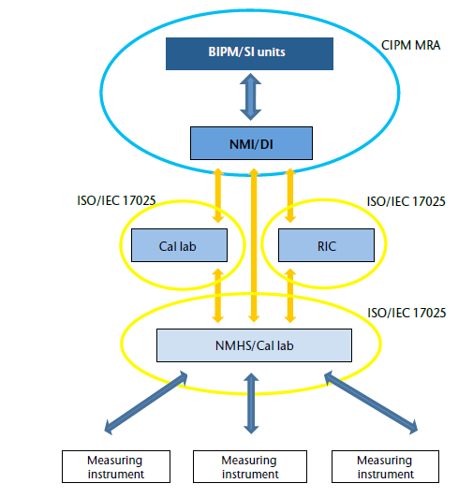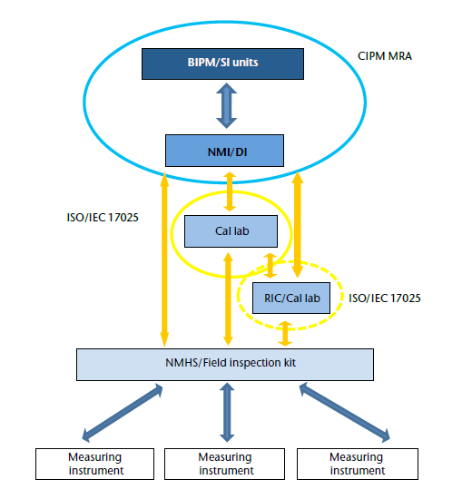

**Figure 1.** Examples of different paths for traceability

# Role of Regional Instrument Centres (RICs)

The Role of Regional Instrument Centres ([RICs](https://community.wmo.int/en/activity-areas/imop/Regional_Instrument_Centres)) is to assist Members of the Region, and possibly of other Regions, in calibrating their national meteorological standards. A RIC would consequently normally calibrate only the reference instruments of the other Member, but not the instruments that are deployed in its observing network.

In some cases, it might be possible for a RIC to calibrate the network instruments of other Members, if it has the capabilities/resources to do so, but this is not the norm. The RIC may request payment for such services that go beyond its nominal role.

It should be noted that RICs are designated by WMO Regional Associations, to provide services to the Region. Some Members are operating calibration laboratories for their own purposes. These are not considered as RICs if they are not designated as such by relevant regional association.

# Approaches to achieve traceability

Different approaches can be considered to achieve the traceability based on the resources available for the operation and maintenance of the stations and calibration of the instruments.

The strategy can include mixed approaches for different meteorological variables (for example, having a calibration laboratory for temperature and pressure which is defined as level 3 below, but relying on the use of the field verification kit for humidity and precipitation which is defined as level 1 below).

Peer advisors should select the option that best aligns with the county’s capabilities during the gap analysis while considering long-term compliance and sustainability. Ultimately, they should strive for the highest levels. However, all options proposed below remain acceptable for GBON implementation under SOFF.

A suitable approach should be determined after making a comprehensive assessment of the capacities of NMHS, available capacities for calibration at the national level, possible calibration services from Regional Instrument Centers ([RICs](https://community.wmo.int/en/activity-areas/imop/Regional_Instrument_Centres)), National Metrology Institutes ([NMIs](https://www.bipm.org/en/cipm-mra/participation)) and other Third-party entities.

It should be noted that it is recommended to follow a stepwise approach, steadily improving the capacity of the Member, rather than opting directly for an ideal solution that may not be sustainable. (For example, it is not recommended to establish a calibration laboratory, before regular maintenance of the stations is achieved in a sustainable manner.)

In all cases, it will be necessary to ensure that the reference instruments (instruments used as references in the laboratory, as well as in the field verification kits) are calibrated on a regular basis.

Calibration intervals for the field instruments should be determined for each sensor considering the recommendations from the manufacturers, operation conditions, environmental exposure and the user requirements (e.g. NWP only, or NWP and climate monitoring).

It should be kept in mind that, for any approach, preventive and corrective maintenance of the stations should be performed within the scope of an operation and maintenance plan.

All activities performed within the traceability assurance strategy should be well documented.

**Caution:** It should also be noted that after calibration, a field instrument may have to be adjusted to provide accurate measurements. After the adjustment, the instrument must be calibrated again before use, to ensure that the adjustment was implemented properly and that the instrument functions within expected specifications.

Below, three different paths are proposed, listed in increasing levels of complexity, as well as in increased levels of confidence.

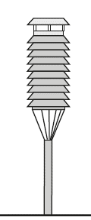Level 1: 

Field verification kit(s) Maintenance/Spare parts/instruments

Level 2:  

Field verification kit(s) Maintenance/Spare parts/instruments Calibration Service Contract with third party

Level 3: 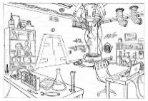

Field verification kit(s) Maintenance/Spare parts/instruments NMHS calibration lab.

**Figure 2.** Different approaches to traceability and critical contributors (in order of complexity)

## LEVEL 1: Traceability assurance using only field verification kits

* NMHSs which do not have the means to operate calibration laboratories, and for which it is complicated to rely on the calibration of their field instruments by third parties can perform regular field verification of their instruments by using a field verification kit. The following should be considered for this approach:
* Field verification is not equivalent to a calibration in a laboratory (see definitions in the appendix). It is basically a one or two-point check using a field verification kit to ensure that the instrument under verification does not show obvious misfunction.
* The field verification kit must meet required metrological specifications and include calibration certificates from NMI, RIC, or calibration laboratories preferably with ISO/IEC 17025 accreditation.
* Field verification offers the ability to check/verify instrument performance on site.
* Field verification can be implemented by NMHSs without calibration laboratories but is also useful for those operating a calibration laboratory.
* Verification is usually done at one or two points against the working standard by placing the working standard as close to the instrument under verification (IUV) as possible.
* Field verification kit must be periodically recalibrated in a calibration laboratory (preferably an ISO/IEC 17025 accredited laboratory such as a RIC, National Metrology Institute (NMI), or other entity). Recalibration should be performed preferably on a yearly basis (but not exceeding 2 years).
* Technical procedures for operating the field verification kit should be documented and followed during the field verification of the instruments.
* When a field instrument is found not to meet the stated tolerance, it must be replaced by a calibrated (new or recalibrated) instrument. The faulty instrument will have to be sent for repair and will have to be recalibrated in a laboratory before further use.
* Two field verification kits may be necessary to ensure continuity of operations when one of the kits is sent for recalibration. In SIDS and large countries, more kits might be necessary for logistical (transport) reasons.

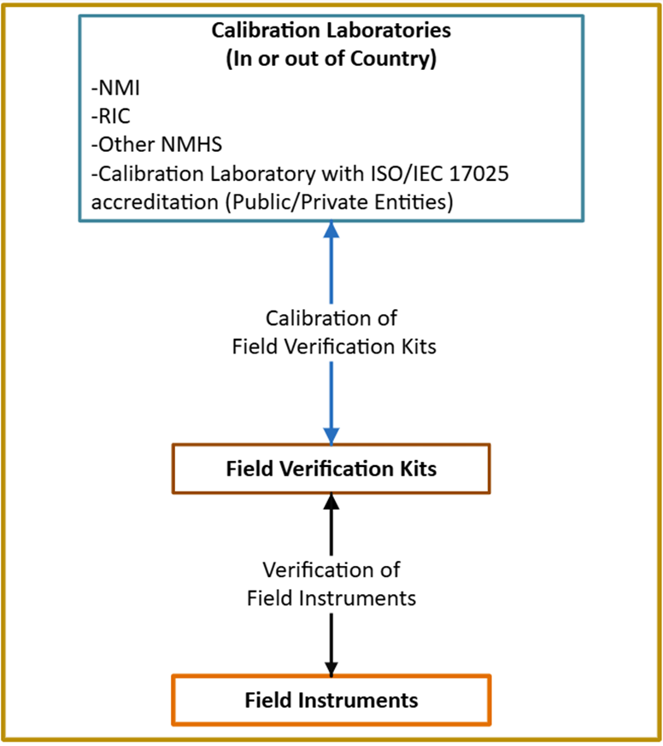

**Figure 3.** Traceability paths for Level 1 showing traceability path from the calibration authority via the verification kit to the field instrument.

## LEVEL 2: Traceability, relying on calibration service provided by an independent calibration laboratory or other NMHSs

If the NMHS lacks the capacity to establish or operate a calibration laboratory, arrangements can be made with third parties to perform the regular calibration of the NMHS instruments.

* Possible providers of such services include:
  + Within the country:
    - Public or private entities (including some manufacturers), with ISO/IEC 17025 accreditation, providing relevant calibration services.
  + Outside of the country:
    - Regional Instrument Centres (RICs, preferably with ISO/IEC 17025 accreditation).
    - Calibration laboratory from another NMHS (preferably with ISO/IEC 17025 accreditation), with sufficient capacity to provide calibration services.
    - Other public or private entities (including some manufacturers) with ISO/IEC 17025 accreditation providing relevant calibration services.
* The costs and logistical implications of this approach need to be carefully considered (transportation, customs, agreement with third party, etc.).
* **Field verification:**
  + The use of field verification kits is also recommended here to perform regular checks on the field instruments, as detailed in Level 1 above.
  + Field verification can increase the period between calibrations of the instruments and support the traceability assurance activities.

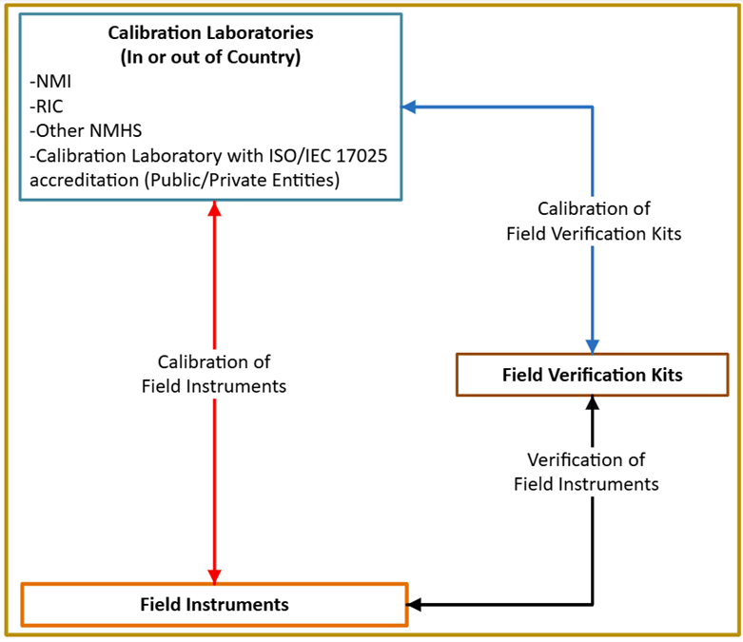

**Figure 4.** Traceability paths for Level 2 showing traceability path from the calibration authority directly to field instruments with supporting verification via the field verification kit to the field instruments.

## LEVEL 3: Traceability with calibration laboratories operated by NMHS

NMHS operating laboratories (existing or to be established) need to consider the staff and funding required to operate the laboratory, to ensure the traceability of the reference instruments, and to calibrate the instruments:

* Sufficient capacity of technical infrastructure, well-trained and competent staff and funding for operating laboratories (existing or to be established).
* If a new laboratory is to be established, it is recommended to limit the scope of the laboratory to one or two parameters, starting with temperature and/or pressure. (Definitely not starting with the establishment of a wind tunnel that is much more challenging to operate and maintain).
* Development of calibration procedures (Standard Operating Procedures (SOPs)) preferably in accordance with ISO/IEC 17025 standard (ISO/IEC 17025 accreditation is optional, but strongly recommended if the laboratory provides calibration services to other Members).
* The quality management system, including all the calibration procedures, working instructions and forms, is well documented and applied in calibration process.
* Reference instruments of the calibration laboratories must be traceable to SI and regularly calibrated, preferably by a laboratory that has ISO/IEC 17025 accreditation. Options to calibrate the reference instruments are:
  + Within the country:
    - The National Metrology Institute (NMI)
    - Other public or private entities (including some manufacturers), with ISO/IEC 17025 accreditation, providing relevant calibration services.
  + Outside of the country:
    - Regional Instrument Centres (RICs, preferably with ISO/IEC 17025 accreditation).
    - Calibration laboratory from another NMHS (preferably with ISO/IEC 17025 accreditation).
    - National Metrology Institutes (NMIs) of other countries (<https://www.bipm.org/en/cipm-mra/participation>).
    - Other public or private entities (including some manufacturers), with ISO/IEC 17025 accreditation, providing relevant calibration services.
* The costs and logistical implications of this approach need to be carefully considered (specific staff competencies, resources needed for the operation of the laboratory including arrangements for the regular calibration of the reference instruments, logistic for transportation of the instrument to the laboratory, etc.).
* **Field verification**
  + In this approach, the use of field verification kits is also recommended to perform regular checks on the field instruments, as detailed in Level 1 above.
  + Field verification can increase the period between calibrations of the instruments and support the traceability assurance activities.

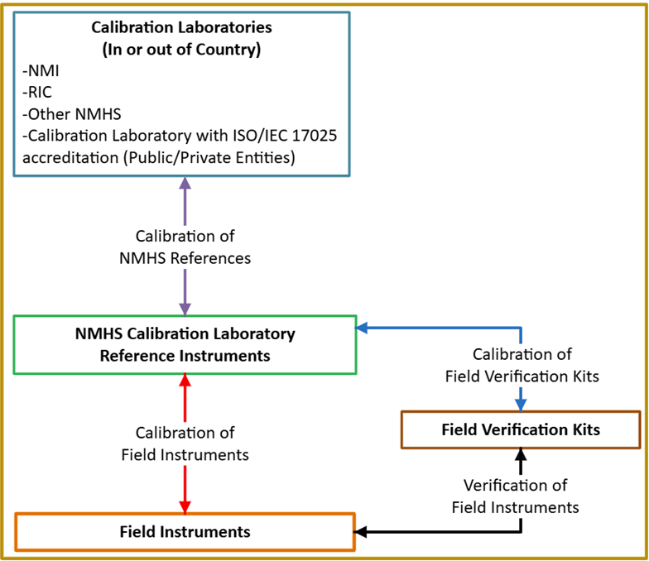

**Figure 5.** Traceability paths for Level 3 through NMHS own accredited laboratories for both field instruments and verification kits.

# Spare part management

* The approach to, spare part management for the instruments used in the stations, field verification kits, and calibration laboratories should be defined as an important component of the operation and maintenance (O&M) plan.
* Sufficient spare parts and spare instruments need to be available to ensure continuity of operations when an instrument is under calibration.

# Control of the observing site

Site maintenance is equally important to ensure traceability. Regular checks within the Operation and Maintenance plan should address among other:

* **Environmental factors**: Obstacles, vegetation, and changes to siting classifications (refer to [WMO-No. 8, Volume I, Chapter 1, Annex 1.D](https://library.wmo.int/viewer/68695/download?file=8_I-2023_en.pdf&type=pdf&navigator=1)).
* **Vegetation management**: Cutting vegetation and maintaining instrument fields.
* **Infrastructure maintenance**: Fencing, corrosion prevention, and structural support.
* **Power supply**: Cleaning solar panels, replacing batteries, and maintaining surge protection systems.
* **Instrument cleaning**: Performed regularly according to user manuals.

# Availability of skilled personnel

The availability and expertise of personnel are essential for effective and sustainable calibration operation and traceability assurance. (see [Guide to Competency](https://library.wmo.int/idurl/4/55828) (WMO-No. 1205) and [Compendium of WMO Competency Frameworks](https://library.wmo.int/idurl/4/56877) (WMO-No. 1209) and [WMO-No. 8, Vol V, Ch. 5](https://library.wmo.int/idurl/4/68663))

* **Competent Staff for Calibration Laboratories:**
  + Ensure compliance, accuracy, quality assurance, and troubleshooting.
  + Operate and maintain calibration equipment.
  + Make arrangements for regular calibration of the reference instrument and maintenance of the laboratory in general.
  + Details are provided in WMO-No. 1209, Sect. 2.7.3 [Competency framework for personnel performing instrument calibrations](https://library.wmo.int/idviewer/56877/105)
* **Competent Staff for maintenance:**
  + Performing preventive and corrective maintenance of the stations
  + Using field verification kit to check instrument performance
  + Details are provided in WMO-No. 1209, Sect. 2.7.2 [Competency framework for personnel installing and maintaining instrumentation](https://library.wmo.int/idviewer/56877/100)
* **Continuous Training and Capacity Development:**
  + Training of the staff performing the activities defined for each of the approach is important to ensure and maintain the traceability.
  + Ongoing and regular training should be provided for the staff performing the maintenance of the stations, using the field verification kits, and making calibration in the laboratories, whichever are applicable.
  + Training programs provided and collaborations with manufacturers, [WMO RICs](https://community.wmo.int/en/activity-areas/imop/Regional_Instrument_Centres), [Regional Training Centers (RTCs)](https://community.wmo.int/en/wmo-regional-training-centres), NMIs and relevant organizations (see [WMO-No. 8, Volume V, Chapter 5](https://library.wmo.int/viewer/68663/download?file=8_V-2023_en.pdf&type=pdf&navigator=1))
  + Webinar on Calibration approaches for the instruments at GBON stations [SOFF: Webinar on calibration approaches for the instruments at GBON stations | ETRP Moodle Site](https://etrp.wmo.int/mod/page/view.php?id=27353&forceview=1)
  + [INFCOM Capacity Development Materials Dashboard](https://community.wmo.int/en/capacity-development-materials-dashboard)

# Annex: Definitions

**Adjustment**

Set of operations carried out on a measuring system so that it provides prescribed indications corresponding to given values of a quantity to be measured. Adjustment of a measuring system should not be confused with calibration, which is a prerequisite for adjustment.

Caution: Adjustments should only be performed in a laboratory following a calibration. After the adjustment, the instrument must be calibrated again before use, to ensure that the adjustment was implemented properly and that the instrument functions within expected specifications.

**Calibration**

Operation that, under specified conditions, in a first step, establishes a relation between the quantity values with measurement uncertainties provided by measurement standards and corresponding indications with associated measurement uncertainties and, in a second step, uses this information to establish a relation for obtaining a measurement result from an indication.​

NOTE 1: A calibration may be expressed by a statement, calibration function, calibration diagram, calibration curve, or calibration table. In some cases, it may consist of an additive or multiplicative correction of the indication with associated measurement uncertainty.

NOTE 2: Calibration should not be confused with adjustment of a measuring system, often mistakenly called “self-calibration”, nor with verification of calibration.​

**Field verification:**

Field verification offers the user the ability to check the instrument on site. Leaving the instrument installed at a meteorological station eliminates any downtime that would occur while removing and reinstalling the instrument in the field. Verification is usually done at one point against the working standard by placing the working standard as close to the instrument under verification (IUV) as possible.

Stabilization time must be allowed to reach temperature equilibrium between the working standard and the IUV. Attention must be paid to the proximity of the working standard to the IUV, the temperature gradients, the airflow, the pressure differences and any other factors that could influence the verification results.

This field verification is an effective way to verify the instrument quality. The most important disadvantage is that the verification is usually limited to one point. The second disadvantage is that if an error is reported, the IUV should be removed and replaced by a new calibrated sensor. Then the IUV has to be calibrated and adjusted, if possible, in a laboratory.

It should also be noted that the field verification provides additional valuable information as it involves testing the whole instrumental set‑up in the field, including cabling, and the like. When performing field verification, it is important that the metadata of the conditions at the time of the verification be recorded, including all details on the changes made to the instrumental set‑up (see additional details provided in WMO-No.8, Volume III, Chapter 1, 1.7).

**Traceability**

A property of the result of a measurement whereby it can be related to stated references, usually national or international standards, through an unbroken chain of comparisons all having stated uncertainties.

This underpins all meteorological and climate science.​