**Annex III A. Country Hydromet Diagnostics report template.**

# COUNTRY HYDROMET DIAGNOSTICS

Informing policy and investment decisions for high-quality weather forecasts, early warning systems, and climate information in developing countries.



(Month) 202Y

(Country NMHS) Peer Review Report

Reviewing Agency: (Name of Peer Reviewing Agency)

Authors: (Author list)

(Organisational logos: Peer Reviewing Agency, Country NMHS, Implementing Entity, SOFF, WMO, Alliance for Hydromet Development)

Copyright (optional)

© (Peer reviewing agency), 20––

The right of publication is reserved by (Peer Reviewing Agency). No part of this publication may be reproduced, distributed, or transmitted in any form or by any means, including photocopying, recording, or other electronic or mechanical methods, without the prior written permission of the (Peer Reviewing Agency). Short extracts may be reproduced without authorization, provided that the complete source is clearly indicated. Editorial correspondence and requests to publish, reproduce or translate this publication in part or in whole should be addressed to:

(WMO PR of Peer Reviewing Agency):

(Address details and signature)

with a copy to (WMO PR of Country NMHS):

(Address details and signature)

The findings, interpretations and conclusions expressed are those of the named authors alone and do not necessarily reflect those of the agencies involved.

Authorisation for release of this report has been received from the Peer Reviewing Agency and the Country NMHS as of (date).

Disclaimer

This report has been prepared based on information and analysis provided by [the Peer Reviewing Agency]. While reasonable care and skill has been taken in preparing this report, no representation or warranty, expressed or implied, is made as to the accuracy, completeness, or suitability of the information and assumptions relied upon, and we do not accept any liability whatsoever for any direct or consequential loss arising from any use of this report or its contents.

Acknowledgements (Optional)

(text)

Table of Contents

COUNTRY HYDROMET DIAGNOSTICS i

Copyright ii

Acknowledgements ii

Table of Contents iii

Executive Summary 1

Chapter 1: General information 2

Introduction 2

CHD methodology 2

Country status 2

Key service needs and natural hazards vulnerabilities 2

Chapter 2: Country Hydromet Diagnostics 2

Element 1: Governance and institutional setting 2

Element 2: Effective partnerships to improve service delivery 2

Element 3: Observational infrastructure 3

Element 4: Data and product sharing and policies 3

Element 5: Numerical model and forecasting tool application 4

Element 6: Warning and advisory services 4

Element 7: Contribution to Climate Services 4

Element 8: Contribution to hydrology 5

Element 9: Product dissemination and outreach 5

Element 10: Use and national value of products and services 5

Chapter 3: Discussion and general recommendations 6

Annex 1 Schedule of consultations (including experts and stakeholder sessions) 7

Annex 2 Urgent needs reported 8

Annex 3 Information supplied through WMO 9

Annex 4 List of materials used 10

Executive Summary

Provide here an overview of critical gaps (e.g. areas that require immediate attention) and general recommendations. Include here a graph summarizing scores (you can use the excel tool to produce the summary graph).

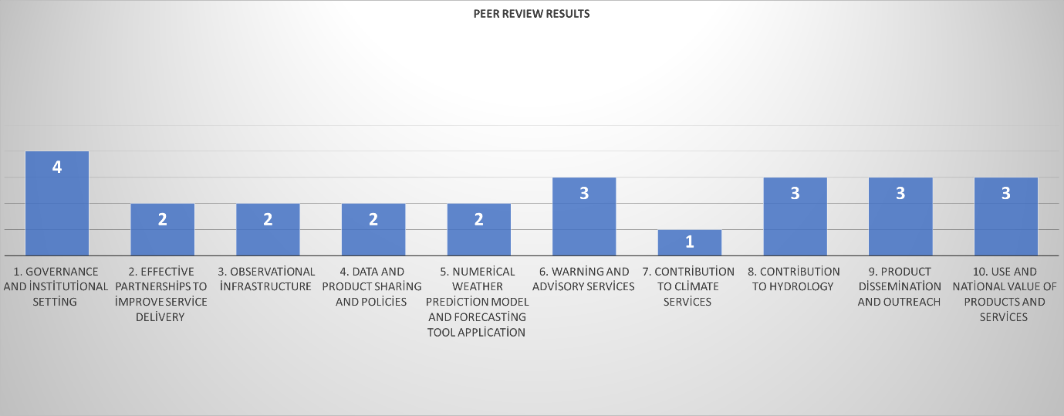

|  |  |
| --- | --- |
| **Element** | **Maturity level score** |
| 1. Governance and institutional setting | Insert score here (1-5) |
| 1. Effective partnerships to improve service delivery | Insert score here (1-5) |
| 1. Observational infrastructure | Insert score here (1-5) |
| 1. Data and product sharing and policies | Insert score here (1-5) |
| 1. Numerical weather prediction model and forecasting tool application | Insert score here (1-5) |
| 1. Warning and advisory services | Insert score here (1-5) |
| 1. Contribution to climate services | Insert score here (1-5) |
| 1. Contribution to hydrology | Insert score here (1-5) |
| 1. Product dissemination and outreach | Insert score here (1-5) |
| 1. Use and national value of products and services | Insert score here (1-5) |

Chapter 1: General information

Introduction

(text)

CHD methodology

(text)

Chapter 2: Country Hydromet Diagnostics

Element 1: Governance and institutional setting

1.1 Existence of Act or Policy describing the NMHS legal mandate and its scope

(Summary and comments)

**1.2 Existence of Strategic, Operational and Risk Management plans and their reporting as part of oversight and management.**

(Summary and comments)

**1.3 Government budget allocation consistently covers the needs of the NMHS in terms of its national, regional, and global responsibilities and based, among others, on cost-benefit analysis of the service. Evidence of sufficient staffing to cover core functions**

(Summary and comments)

1.4 Proportion of staff (availability of in-house, seconded, contracted- out) with adequate training in relevant disciplines, including scientific, technical, and information and communication technologies (ICT). Institutional and policy arrangements in-country to support training needs of NMHS.

(Summary and comments)

**1.5 Experience and track record in implementing internationally funded hydromet projects as well as research and development projects in general.**

(Summary and comments)

**Summary score and recommendations for Element 1**

Element 2: Effective partnerships to improve service delivery

**2.1. Effective partnerships for service delivery in place with other government institutions.**

(Summary and comments)

2.2. Effective partnerships in place at the national and international level with the private sector, research centres and academia, including joint research and innovation projects.

(Summary and comments)

**2.3. Effective partnerships in place with international climate and development finance partners.**

(Summary and comments)

**2.4. New or enhanced products, services or dissemination techniques or new uses or applications of existing products and services that culminated from these relationships.**

(Summary and comments)

**Summary score, recommendations, and comments for Element 2**

Element 3: Observational infrastructure

**3.1. Average horizontal resolution in km of both synoptic surface and upper-air observations, including compliance with the Global Basic Observing Network (GBON) regulations.**

(Summary and comments)

**3.2. Additional observations used for nowcasting and specialized purposes.**

(Summary and comments)

**3.3. Standard Operating Practices in place for the deployment, maintenance, calibrations and quality assurance of the observational network.** (Summary and comments)

**3.4 Implementation of sustainable newer approaches to observations.**

(Summary and comments)

3.5. Percentage of the surface observations that depend on automatic techniques.

(Summary and comments)

**Summary score, recommendations, and comments for Element 3**

Element 4: Data and product sharing and policies

**4.1. Percentage of GBON compliance – for how many prescribed surface and upper-air stations are observations exchanged internationally. Usage of regional WIGOS centres.**

(Summary and comments)

**4.2. A formal policy and practice for the free and open sharing of observational data.**

(Summary and comments)

**4.3. Main data and products received from external sources in a national, regional and global context, such as model and satellite data.**

(Summary and comments)

**Summary score, recommendations, and comments for Element 4**

Element 5: Numerical model and forecasting tool application

**5.1. Model and remote sensed products form the primary source for products across the different forecasting timescales.**

(Summary and comments)

**5.2. a) Models run internally (and sustainably), b) Data assimilation and verification performed, c) appropriateness of horizontal and vertical resolution.**

(Summary and comments)

**5.3. Probabilistic forecasts produced and, if so, based on ensemble predictions.**

(Summary and comments)

**Summary score, recommendations, and comments for Element 5**

Element 6: Warning and advisory services

**6.1. Warning and alert service cover 24/7.**

(Summary and comments)

**6.2. Hydrometeorological hazards for which forecasting and warning capacity is available and whether feedback and lessons learned are included to improve warnings.**

(Summary and comments)

**6.3. Common alerting procedures in place based on impact-based services and scenarios taking hazard, exposure and vulnerability information into account and with registered alerting authorities.**

(Summary and comments)

**Summary score, recommendations, and comments for Element 6**

Element 7: Contribution to climate services

**7.1. Where relevant, contribution to climate services according to the established capacity for the provision of climate services.**

(Summary and comments)

**Summary score, recommendations, and comments for Element 7**

Element 8: Contribution to hydrology

**8.1. Where relevant, standard products such as quantitative precipitation estimation and forecasts are produced on a routine basis according to the requirements of the hydrological community.**

(Summary and comments)

**8.2. SOPs in place to formalize the relation between Met Service and Hydrology Agency, showing evidence that the whole value chain is addressed.**

(Summary and comments)

**8.3. Data sharing agreements (between local and national agencies, and across international borders as required) on hydrological data in place or under development.**

(Summary and comments)

**8.4 Joint projects/initiatives with hydrological community designed to build hydrometeorological cooperation.**

(Summary and comments)

**Summary score, recommendations, and comments for Element 8**

Element 9: Product dissemination and outreach

**9.1. Channels used for user-centred communication and ability to support those channels (for example, does the NMHS operate its own television, video or audio production facilities? Does it effectively use cutting-edge techniques?).**

(Summary and comments)

**9.2. Education and awareness initiatives in place.**

(Summary and comments)

**9.3. Special measures in place to reach marginalized communities and indigenous people.**

(Summary and comments)

**Summary score, recommendations, and comments for Element 9**

Element 10: Use and national value of products and services

**10.1. Formalized platform to engage with users sin order to co-design improved services.**

(Summary and comments)

**10.2. Independent user satisfaction surveys are conducted, and the results used to inform service improvement.**

(Summary and comments)

**10.3. Quality management processes that satisfy key user needs and support continuous improvement.**

(Summary and comments)

**Summary score, recommendations, and comments for Element 10**

Annex 1 Consultations (including experts and stakeholder consultations)

(list major consultations and other activities during the CHD process)

Annex 2 Urgent needs reported

(This summarises information about needs that have been identified as particularly pressing. It could, for example, show significant matters that require immediate attention, or notable illustrations of country needs.)

Annex 3 Information supplied through WMO

(This summarises information collected from WMO databases in response to questionnaires and other information gatherings. Furthermore, the feedback of the Peer-reviewers will be crucial for validating WMO self-reported data and collecting data from no-data countries.)

Annex 4 List of materials used

(this may include WMO guidance materials, data and information, review reports, databases etc.)